Title of the article

A. Auhtorª, B. Auhtor

ª Silesian University of Technology, Faculty of Mechanical Engineering, Department of Engineering Materials and Biomaterials
email: xxxx@polsl.pl

Abstract: Describe briefly what the article is about and what has been done.
For example: The article describes the idea of the atomic layer deposition method and its possible applications. Also presented are the exemplary test results of Al2O3 thin layers deposited by the ALD method on the Picosun R-200 system.

Keywords: materials, laser treatment, polimers

1. INTRODUCTION

All text is written on the maximum 8 pages in Times New Roman size 12 font, main points are written in CAPITAL LETTERS in bold, and sub-points are written "normal" also in bold.
The first line of the paragraph is indented 0.5 cm and the line spacing is 1 line (single), the text is justified.

1.1. Sub-point

References to the literature are placed in square brackets []. Bullets are dots (indent the first line and other lines (protrusion) 0.5 cm from the dot, protrusion of the dot 0) as in the example below:
• XXX
using subnumbering as in the example below:
▪ XXX
Numbering (first line indentation and other lines (protrusion) 0.5 cm, digit 0 protrusion) as in the example below:
1. xxxx
Descriptions of drawings justified: in Polish (simple text) and in English (italics), as shown in the example below:
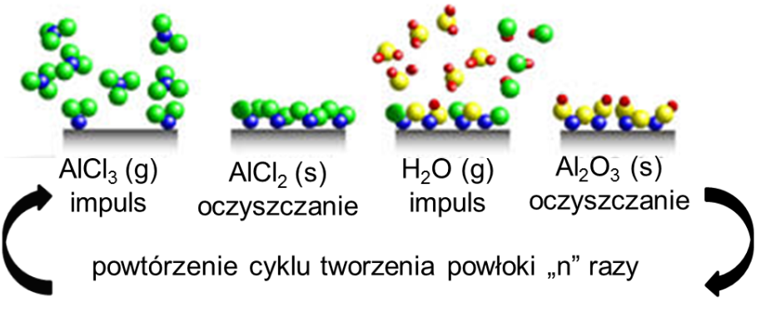

Figure 1. Deposition of Al₂O₃ monolayer by ALD method

Descriptions of tables justified: in Polish (simple text) and in English (italics), as shown in the example below. Board border ½ point, width 16 cm.

Table 1. Technical specifications High temperature vacuum furnace HT-2100-G-Vac-Graphit-Special the company LINN
xxx | xxx | xxx

BIBLIOGRAPHY

- H.S. Nalwa (ed.), Handbook of thin film materials Vol. 1, Deposition and processing of thin films, Academic Press, San Diego, 2002.
- T. Suntola, J. Anlson, U.S. Patent 4,058.430, 1977.
- L.A. Dobrzański, A.D. Dobrzańska-Danikiewicz, Obróbka powierzchni materiałów inżynierskich, Open Access Library, Volume 5, 2011.
- Atomic Layer Deposition, Beneq, http://www.beneq.com/atomic-layer-deposition.html, 2013.
- G. Łuka, Warstwy ZnO i ZnO:Al otrzymane metodą osadzania warstw atomowych do zastosowań w organicznej elektronice, Rozprawa doktorska, Polska Akademia Nauk, Warszawa, 2011.
- F. Li, L. Li, X. Liaoa, Y. Wanga, Precise pore size tuning and surface modifications of polymeric membranes using the atomic layer deposition technique, Journal of Membrane Science 385-386 (2011) 1-9.

